**Master Functional Document**

|  |  |
| --- | --- |
| **Application** | NGERP – Centra |
| **Service Bundle** | Master Management |
| **Service Request** | Document Base Type |

**Desctiption:**

In Compiere (NGERP - Centra), the Accounting Document Base Type defines how transaction records are accounted for. It enables the creation of custom documents and accounting rules. Users assign a unique alphanumeric code for custom base types and must implement the AccountingInterface for proper integration.

**Workflow Process:**

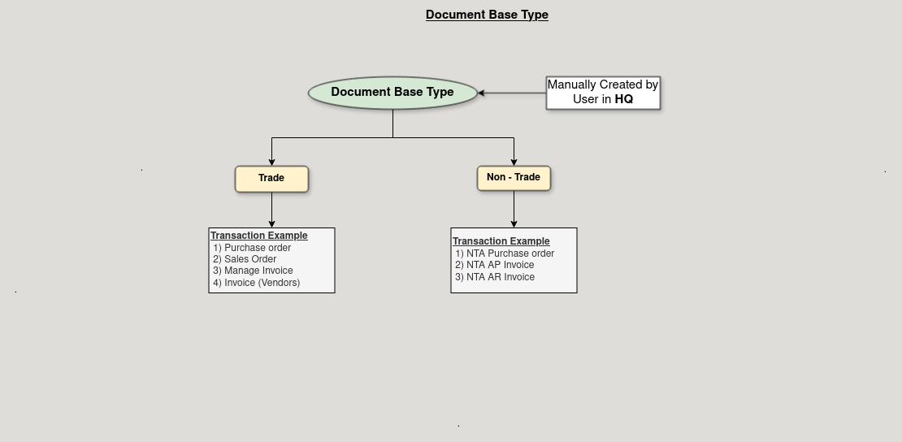

**Business Rules:**

* Document Base Types are visible in both HQ and ROW.
* Creation of Document Base Types are possible in both HQ and ROW.
* Deactivation of Document Base Types is allowed to prevent future use while maintaining history.
* Document Base Type defines how transactions are accounted for in the system.
* Unique alphanumeric code must be assigned for custom document base types.